**INFRASTRUCTURE AS A SERVICE (IAAS)**

**EXPERIMENT – 19**

**AIM:**

To demonstrate Infrastructure as a Service (IaaS) by creating a resource group using a public cloud service provider (Azure), and configure it with minimum CPU, RAM, and storage.

**PROCEDURE:**

1. Login to the Microsoft Azure Portal by navigating to https://portal.azure.com and sign in with your Azure credentials.
2. Click on "Resource Groups" from the left-hand menu and then select "+ Create".
3. Choose your subscription and enter a unique name for the resource group such as "TestIaaS-RG".
4. Select an appropriate region like "Central India", click "Review + Create", and then click "Create".
5. After the resource group is created, go to "Virtual Machines" and click on "+ Add" followed by "Virtual Machine".
6. Enter the details such as subscription, the previously created resource group, and a virtual machine name like "testVM".
7. Select the same region as your resource group and choose a lightweight OS image such as Ubuntu 20.04 LTS.
8. Choose a minimum configuration for the VM like the B1s size with 1 vCPU and 1 GB RAM.
9. Set up authentication using either a password or SSH key.
10. Allow public inbound ports such as SSH (for Linux VMs) or RDP (for Windows VMs).
11. Click on "Review + Create" and then click "Create" to deploy the virtual machine.
12. After deployment, go to "Virtual Machines", select the deployed VM, and verify the configuration details for CPU, RAM, and storage.
13. Optionally, connect to the VM using SSH or RDP to test access.
14. To avoid unnecessary charges, go to "Resource Groups", select your resource group, and delete it when finished.

**OUTPUT:**

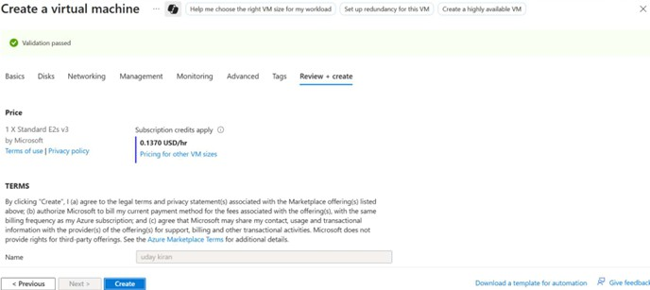

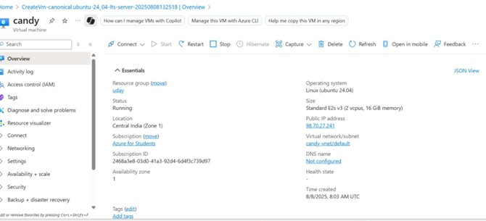

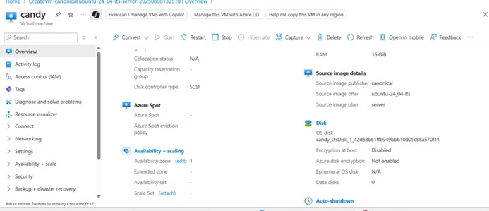

**RESULT:**

Successfully demonstrated Infrastructure as a Service (IaaS) by deploying a virtual machine with minimal resources using Microsoft Azure and organizing it under a newly created resource group.